# **Rotation Report**

**Winter 2015**

Kanishk Asthana [kasthana@eng.ucsd.edu](mailto:kasthana@eng.ucsd.edu)

Project Links: [GitHub](https://github.com/kanishkasthana/compareChipSeq), [Google Drive](https://drive.google.com/folderview?id=0B6aRfRgg95OGTGdrNDRVYmNXQXc&usp=sharing)

## **Introduction**

[HOMER](http://homer.salk.edu/homer/) is a motif discovery and Next-generation sequence analysis software package which was originally created in the Glass Lab. HOMER is used for multiple types of analysis in the lab including for calling peaks in Chip-Seq data. There are multiple programs currently available for calling Chip-Seq peaks, however it is not known how HOMER performs relative to these other programs.

The objective of this rotation was to compare HOMER to other popular Chip-Seq calling programs. Another objective was to assess whether the lab should continue using HOMER or switch to another program which performs better. The most comprehensive study done for comparing Chip-Seq programs was by [Wilbanks et. al.](http://journals.plos.org/plosone/article?id=10.1371/journal.pone.0011471) and I have used many of the metrics introduced in that study to judge performance.

## **Chip-Seq Candidate Programs Chosen**

Given that there are so many Chip-seq calling programs available, the main limitation for choosing candidate programs became the availability (or lack of) of documentation for these program. Almost all other [programs](https://drive.google.com/file/d/0B6aRfRgg95OGTzZsNmkxUHo5eTA/view?usp=sharing) that I looked at lacked enough documentation to start using them. Given these limitations I chose the following two programs to compare with HOMER:

1. The most popular Chip-seq program so far is [MACS](https://github.com/taoliu/MACS/). MACS was chosen for its popularity and wide adoption. I suspect it is this popular because it is very simple to use and requires only a single line command to generate an output. However, this comes at the cost of lesser flexibility and options as compared to HOMER. Moreover, MACS does not provide information about the strand the peak lies on +/-. This lack of information might hinder downstream analysis.
2. [SISSRS](http://www.rajajothi.com/sissrs/) is another candidate program that was chosen. I found it easy to install and use, however it does not provide information such as strand direction, a unique ID for each peak and a score for each peak found. This lack of information might hinder downstream analysis.

## **Pair wise comparison of shared peaks**

For the pair wise comparison two datasets were initially chosen. The first was a PU.1 Chip-seq dataset generated in the Glass Lab (this dataset can be found at /data/home/kasthana/ mm10-C57BL7-ThioMac-PU1-notx.sam on the Glass Lab server). The second was an [ENCODE data set](https://www.encodeproject.org/experiments/ENCSR000DOB/) ([replicate no 2 was chosen](https://www.encodeproject.org/files/ENCFF000YOK/@@download/ENCFF000YOK.bam)). The R script used to make this comparison can be found [here](https://github.com/kanishkasthana/compareChipSeq/blob/master/checkOverlapofPeaks.R).

**Table 1: Comparison of HOMER vs MACS.**

|  |  |  |
| --- | --- | --- |
| Data Set | HOMER (% of Peaks shared with MACS) | MACS (% of Peaks shared with HOMER) |
| [PU.1](https://docs.google.com/uc?authuser=0&id=0B6aRfRgg95OGczFHclRfU0l5TVE&export=download) | 93.24609 | 90.06348 |
| [ENCODE](https://docs.google.com/uc?authuser=0&id=0B6aRfRgg95OGb0hxdlJxN3k3ME0&export=download) | 74.55422 | 89.26311 |

**Table 2: Comparison of HOMER vs SISSRS**

|  |  |  |
| --- | --- | --- |
| Data Set | HOMER (% of Peaks shared with SISSRS) | SISSRS (% of Peaks shared with HOMER) |
| [PU.1](https://docs.google.com/uc?authuser=0&id=0B6aRfRgg95OGakdnc1lnNlZSQUE&export=download) | 82.0557 | 75.01613 |
| [ENCODE](https://docs.google.com/uc?authuser=0&id=0B6aRfRgg95OGSTE3UUQxLVVnejg&export=download) | 80.47605 | 63.70693 |

**Table 3: Comparison of SISSRS vs MACS**

|  |  |  |
| --- | --- | --- |
| Data Set | SISSRS (% of Peaks shared with MACS) | MACS (% of Peaks shared with SISSRS) |
| [PU.1](https://docs.google.com/uc?authuser=0&id=0B6aRfRgg95OGcUxpU29RRFZmWkk&export=download) | 82.8864 | 87.56901 |
| [ENCODE](https://docs.google.com/uc?authuser=0&id=0B6aRfRgg95OGSDZ1Y3Vhcm9ldDA&export=download) | 63.42505 | 95.92693 |

*{Additional Comparisons made for HOMER vs MACS: for* [*GAPB*](https://docs.google.com/uc?authuser=0&id=0B6aRfRgg95OGY1BKb3VoWm1oX0k&export=download) *(*[*Replicate2*](https://www.encodeproject.org/experiments/ENCSR000BIW/)*) and* [*NRSF*](https://docs.google.com/uc?authuser=0&id=0B6aRfRgg95OGbWU5TTd1eHphNkk&export=download) *(*[*Replicate 2*](https://www.encodeproject.org/experiments/ENCSR000BOX/)*)}*

Looking at the shared peaks information it is clear that the number of shared peaks can be quite variable across programs and datasets. However, is this variability simply because of larger number of peaks called by one program with respect to the other? What about highly ranked peaks? If two programs are finding the same number or percentage of high confidence peaks then it might be that the larger number of peaks we see are simply because of more false positives.

So I decided to test the idea that the larger subset of peaks called by either program might be because of more garbage or false positive peaks found by one program with respect to another. If one program is detecting more garbage peaks then the percentage of shared peaks should increase for both programs for the top 25 percentile of peaks, and for top 5000 peaks with respect to the average. (Both top 25 percentile and top 5000 were arbitrary choices)

SISSRS does not provide a rank or score for its peaks so the analysis from this point onwards was done only for MACs and HOMER. The –logPValue generated was chosen as a scoring metric for MACS (this is identical to the –logQValue metric also generated by MACS as [both scores are perfectly correlated](https://drive.google.com/file/d/0B6aRfRgg95OGQmxxMk5oZTI0X0E/view?usp=sharing)), and the Peak Score generated by HOMER was taken as the scoring metric for HOMER.

*The following scripts were written to filter number of peaks for HOMER and MACS:*

*Returns peaks above x percentile:* [*macsPeakFilter.java*](https://github.com/kanishkasthana/compareChipSeq/blob/master/macsPeakFilter.java)*,* [*homerPeakFilter.java*](https://github.com/kanishkasthana/compareChipSeq/blob/master/homerPeakFilter.java)

*Return top x number of peaks:* [*macsPeakFilterNumeric.java*](https://github.com/kanishkasthana/compareChipSeq/blob/master/macsPeakFilterNumeric.java)*,* [*homerPeakFilterNumeric.java*](https://github.com/kanishkasthana/compareChipSeq/blob/master/homerPeakFilterNumeric.java)

*Returns peaks below x percentile:* [*macsPeakFilterBelow.java*](https://github.com/kanishkasthana/compareChipSeq/blob/master/macsPeakFilterBelow.java)*,* [*homerPeakFilterBelow.java*](https://github.com/kanishkasthana/compareChipSeq/blob/master/homerPeakFilterBelow.java)

*Example:* ***java homerPeakFilter inputHomerPeakFile outPutFile 75***

**Table 4 Comparison of HOMER vs MACS for top 25% and top 5000 peaks**

|  |  |  |  |
| --- | --- | --- | --- |
| **Data Set** | **Type of Peaks** | HOMER (% of Peaks shared with MACS) | MACS (% of Peaks shared with HOMER) |
| **PU.1** | [**Average**](https://docs.google.com/uc?authuser=0&id=0B6aRfRgg95OGczFHclRfU0l5TVE&export=download) | 93.24609 | 90.06348 |
|  | [**Top 25 Percentile**](https://docs.google.com/uc?authuser=0&id=0B6aRfRgg95OGbjNFSnBDTXZMVVE&export=download) | 90.48544 | 85.42430 |
|  | [**Top 5000 Peaks**](https://docs.google.com/uc?authuser=0&id=0B6aRfRgg95OGRXFvYVg0bzdFcnM&export=download) | 82.57576 | 80.66000 |
|  | [**Bottom 25 Percentile**](https://docs.google.com/uc?authuser=0&id=0B6aRfRgg95OGc0NGZ25QeFZsVU0&export=download) | 57.85524 | 51.35473 |
| **ENCODE** | [**Average**](https://docs.google.com/uc?authuser=0&id=0B6aRfRgg95OGb0hxdlJxN3k3ME0&export=download) | 74.55422 | 89.26311 |
|  | [**Top 25 Percentile**](https://docs.google.com/uc?authuser=0&id=0B6aRfRgg95OGbXRCejJmOFJjTUE&export=download) | 77.50584 | 91.39446 |
|  | [**Top 5000 Peaks**](https://docs.google.com/uc?authuser=0&id=0B6aRfRgg95OGOVV2aDI1cXpNRWs&export=download) | 81.40521 | 80.64000 |
|  | [**Bottom 25 Percentile**](https://docs.google.com/uc?authuser=0&id=0B6aRfRgg95OGbTR3cEJkajFQN0U&export=download) | 24.38621 | 25.17400 |

Surprisingly we get mixed results for Table 4. In some cases the number of shared peaks goes up when filtering the top peaks and in some cases it actually decreases. Perhaps this is an example of regression to the mean, not sure what is happening here. This is counterintuitive and **it is unclear which software package performs better.**

## **Motif Analysis**

To check whether the Chip-Seq worked correctly, the lab often does a motif analysis on the detected peaks using HOMER. If the known motif for a transcription factor being ChiP-ed occurs in the region around the detected peaks then it is seen as an indicator that the ChiP worked as planned.

[Motif Analysis on the peaks detected by HOMER](https://github.com/kanishkasthana/compareChipSeq/tree/master/homerPeakMotifs) indeed shows that PU.1 is the most enriched known motif in the sample.

**Figure 1. PU.1 is the most ENRICHED known Motif found in peaks called by HOMER (Enrichement~44%)**



A limitation of MACS is that it does not give information about which strand +/- the peaks lie on in its output. HOMER’s motif analysis functionality requires strand direction index for detecting motifs. One way to get around the problem is to artificially introduce a column for the strand direction “+” in the output for MACS. Given that there are no “-“ strand peaks detected by HOMER in this dataset, this seems like a reasonable assumption to make. However, I am not sure if this assumption should be made for all datasets. The script used to format the peak file from MACS into a format accepted by HOMER can be found [here](https://github.com/kanishkasthana/compareChipSeq/blob/master/macsDataReformat.R). [The Motif Analysis for peaks detected by MACS can be found here.](https://github.com/kanishkasthana/compareChipSeq/tree/master/macsPeaksMotifs)

**Figure 2. PU.1 is the most ENRICHED known Motif found in peaks called by MACS (Enrichement~44%)**

Given that both programs detect PU.1 as the most enriched motifs perhaps it is more important to do a motif analysis on the set of peaks that are only detected by one program or the other. To do this I wrote a [script](https://github.com/kanishkasthana/compareChipSeq/blob/master/getIntersection.R) to filter the peaks in two groups: [one for peaks found only in HOMER and not MACS](https://github.com/kanishkasthana/compareChipSeq/tree/master/homerPeaksNotInMacs), [and another for peaks found only in MACS and not homer](https://github.com/kanishkasthana/compareChipSeq/tree/master/macsPeaksNotInHomer).

**Figure 3. PU.1 is the most ENRICHED known Motif found in peaks found in HOMER and not MACS (Enrichment ~32%)**



**Figure 4. PU.1 is the most ENRICHED known Motif found in peaks found in MACS and not HOMER (Enrichment ~35%)**



Both the dataset show similar levels of enrichment. Moreover, given the variability in number of peaks called by both programs across datasets, I would expect the enrichment levels to vary as well. **From these results it is unclear which program will perform better in all cases.**

### **Detection of qPCR verified True Positives**

[Wilbanks et. al.](http://journals.plos.org/plosone/article?id=10.1371/journal.pone.0011471) used qPCR verified target to detect the ability for various programs to detect the sensitivity for detecting there true positives. There used NRSF and GABP are the target binding proteins in question. I repeated the same analysis for HOMER and MACS to see how HOMER performs relative to other programs.

**Figure 5. Original Analysis done by** [**Wilbanks et. al.**](http://journals.plos.org/plosone/article?id=10.1371/journal.pone.0011471) **on the left panels and figures I generated for HOMER and MACS on the right panels. (Note: the true positive dataset was given in HG18 format, I converted this to HG19 format using** [**this utility**](https://genome.ucsc.edu/cgi-bin/hgLiftOver)**. Dataset used: GAPB (**[**Replicate2**](https://www.encodeproject.org/experiments/ENCSR000BIW/)**) and NRSF (**[**Replicate 2**](https://www.encodeproject.org/experiments/ENCSR000BOX/)**). Script &Data:** [**Script for generating figures**](https://github.com/kanishkasthana/compareChipSeq/blob/master/qPCRComparison.R)**.** [**True Positives Dataset.**](http://journals.plos.org/plosone/article/asset?unique&id=info:doi/10.1371/journal.pone.0011471.s004)

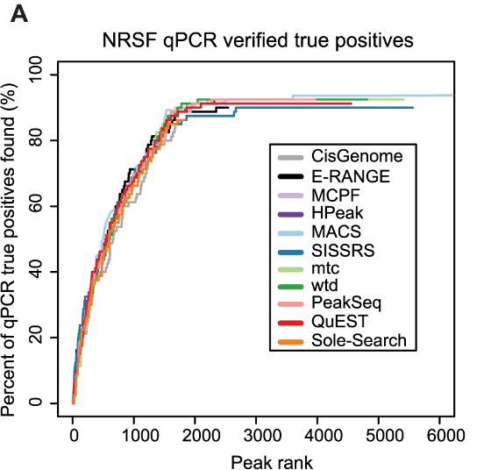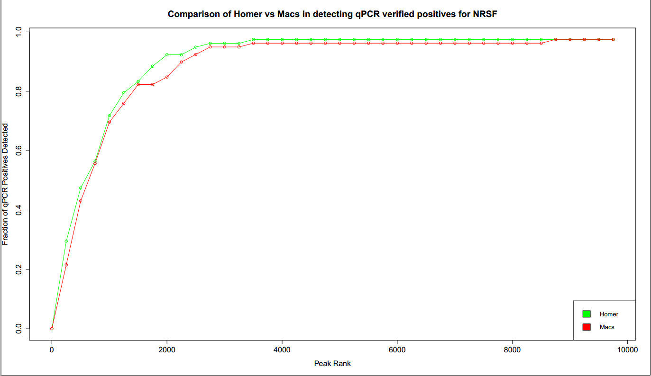

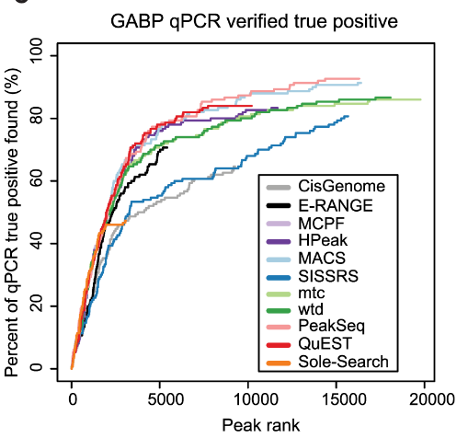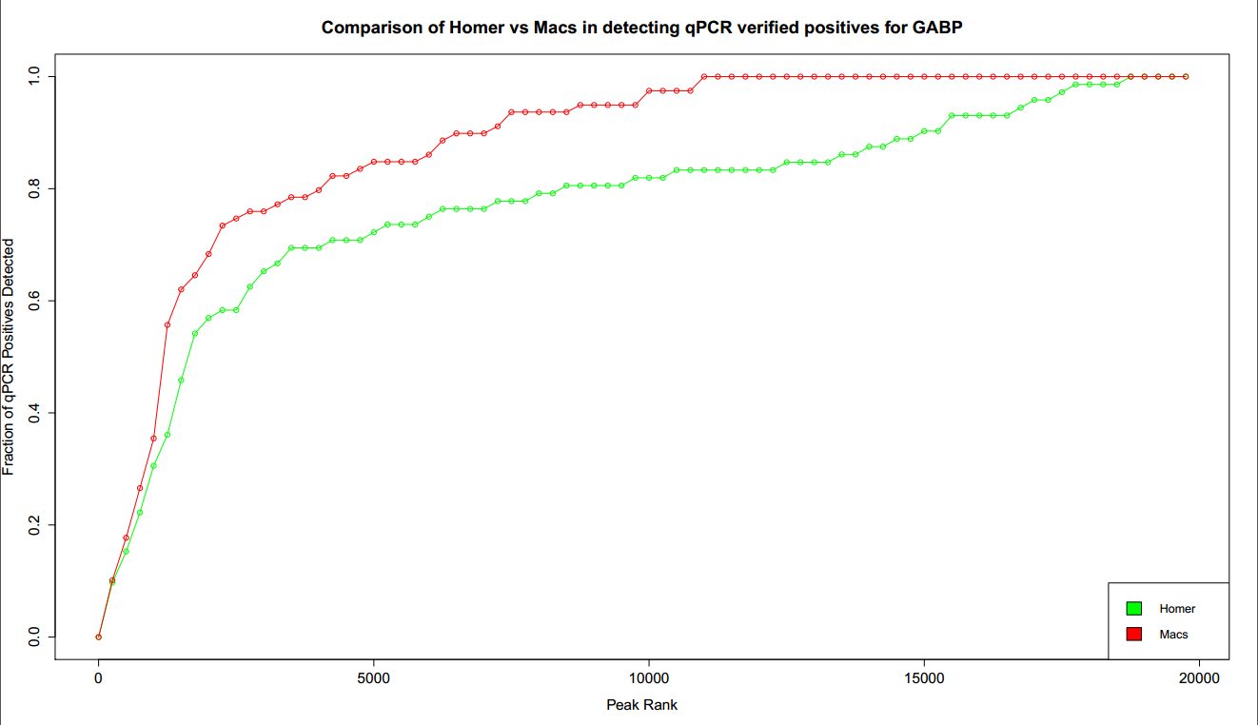

### **Conclusion**

From the true positive detection rate seen in Figure 5 it seems like MACS performs better than HOMER for GABP. Given these limited results it seems like MACS is indeed the better choice. However, considering the variability we have seen for other dataset and that MACS and HOMER perform identically for NRSF, **it is hard to generalize this result and say definitively that one software is better than the other.**